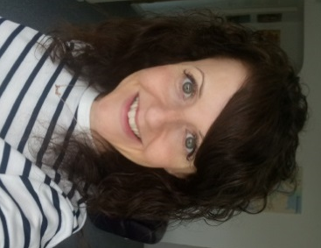 | Hello! My name is Anna Harrison.
 | My job is Inclusion Worker. This means that I make sure that everyone can have a say about our service.
 | This includes what people think about us, and ideas for what else we could do to help children and young people with special educational needs and or disabilities (SEND) in the Wakefield District.
 | Special educational needs means that you need extra help to learn things.
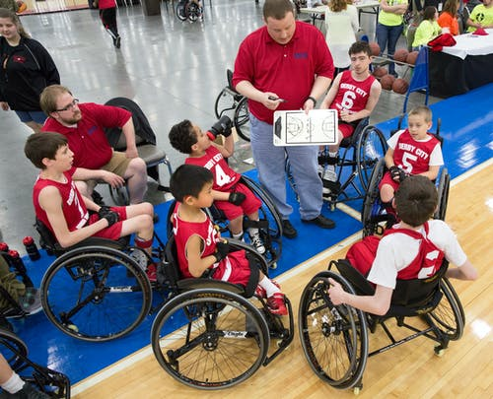 | A disability is a physical or mental need that makes it hard to do things like walk, talk or see.
 | You can call me on 07738 119591.
 | You can email me at:anna.harrison@barnardos.org.uk

