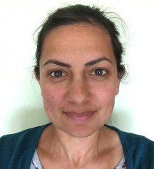 | My name is Usha Gough and I am the SEND Local Offer Lead for Wakefield. SEND stands for Special Educational Needs and / or Disabilities.
 | My job is to collect information that will help children, young people and families with SEND in Wakefield.
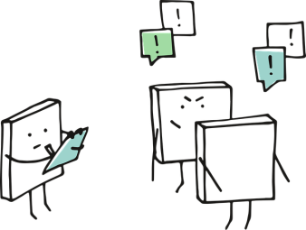 | Part of my job is to find out what information children, young people and families would like.  I listen to and read their ideas and then ask other services if this is available.
 | I work with lots of other people in different services. These people are from Wakefield Council, health and social services, education settings and other groups. Other groups might be charities or parents groups.
 | These people help me get the right information because I might not know everything.
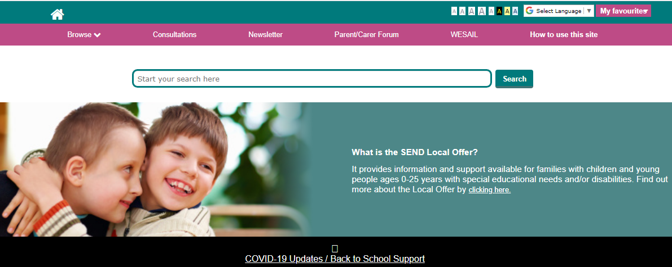 | I put this information all in one place on a website.
 | I put this information on Facebook.
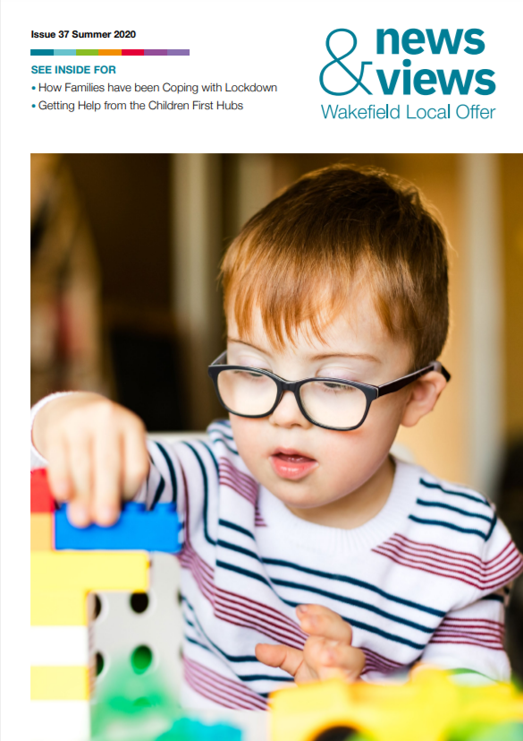 | I also put some of this information into a newsletter.

