Bradford SENDIASS

Education Health and Care Needs Assessment
Parental Request
Click this link to access the online portal
Or
Scan this QR code

Please use this information sheet to support you before you log into the portal to make the parental request. This information sheet will prompt you to gather relevant information and prepare written responses before you access the online request form.

You can also watch the video which shows each step of the portal alongside some hints and tips!
Access the video by clicking this link: https://youtu.be/QecUwvLpf1o
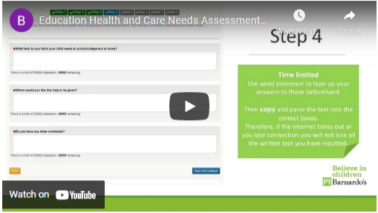
The online form has eight steps in total which are described below:

Step 1
Personal details of the parent/carer submitting the request.

Step 2
NHS number of the child/ Young person

Step 3
Details of professionals currently working with the child/ young person.
Details include (name, role, telephone number and email address)

Step 4
Questions as below (Max 3,000 words per answer):

Do you have any worries about your child’s education health or care? If so, what are they?
- Write what worries you have about your child’s education.
- Write what worries you have about your child’s health.
- Write what worries you have about your child’s care.

What do you think about your child’s education and how they are getting on?
- Write about how you think they are getting on within education.
- Write about what they find easy and their strengths.
- What are they finding difficult or a challenge?
- Are there any barriers they face, that the majority of children of the same age, do not?

What does your child enjoy doing at home and at school/college?
- Make sure you write about their hobbies and interests in school AND at home.

What help do you think your child needs at school/college and at home?
- Write what you are already doing to help your child.
- Write what you think may be helpful for your child at school/college and at home.
- Write about what has worked in the past for your child/young person? Has there been a change in the support?

Where would you like this help to be given?
- You should specify here where this help is to be given. This may include school, home, out of school clubs, childcare or clubs.
- You may also think about the specific times of the day this support is needed.
- You might want to specify support that overlaps different places too.

Is there anything else you think is important to mention?
- If you feel you have not yet had the chance to express why your child/young person requires a EHC needs assessment, you can do that here.

Step 5
Parental consent and/or Young Person’s (over 16yr old) consent

Step 6
Young person’s signature and their nominated person’s details if required.
Young person or parental signature (to be uploaded)

Step 7
Upload documents or reports to support the request. Include but not exclusive to:
- Diagnostic/ medical reports
- Speech and Language reports
- Educational psychologist’s reports
- Exclusion letters
- School reports
- Paediatrician reports
- CAMHS
- Social care

If reports or documents are not available or have not been sought, do not worry, if the Local authority agree to carry out an assessment, they will request certain professionals to undertake assessments that will generate reports.

Step 8
Confirm details are correct and submit the form.

For further information and advice, contact Barnardo’s SENDIASS:
Telephone: 01274 513300 Email: bradfordsendiass@barnardos.org.uk
Write to: Bradford SENDIASS
40–42 Listerhills Science Park
Campus Road
Bradford
BD7 1HR
Or visit our website for more useful information: https://barnardossendiass.org.uk/bradford-sendiass/

