1. Hello, Our service is called Children’s Advocacy and Participation Service (CAPS for short!)  Children’s Advocacy and Participation Service (CAPS)  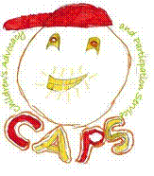  This leaflet tells you about the work we do and how we can support you, it lets you know how to get in touch with us and what to expect when we meet. | 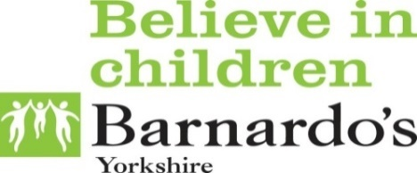  2. We are Advocates; this means we are here to support you; we put children and young people at the centre of everything we do. We only work for you. | 3. We know lots about Children’s rights, and this helps us to help you. We can help you get ready for meetings and make sure people know what you think about any decisions that are being made and what you think would help.
4. Having social care involved with you or your family can sometimes be confusing. We can help you understand what’s going on and why. | 5. You might feel ….  Or you might feel something else? We can help you work out how to tell people how you feel and what you think can make it better. | 6. If we meet with you this can be somewhere you feel comfortable to talk. We usually see you in private away from workers, carers and family. This is how can get in touch with us …  Barnardo's Wakefield CAPS  Castleford Civic Centre  Ferrybridge road  Castleford  WF10 4JH  Phone: 01977 552 493  Free phone: 0800 0121 552  Facebook: Wakefield CAPS  E-mail: wakefieldcaps@barnardos.org.uk  Out of hours 07825377513

