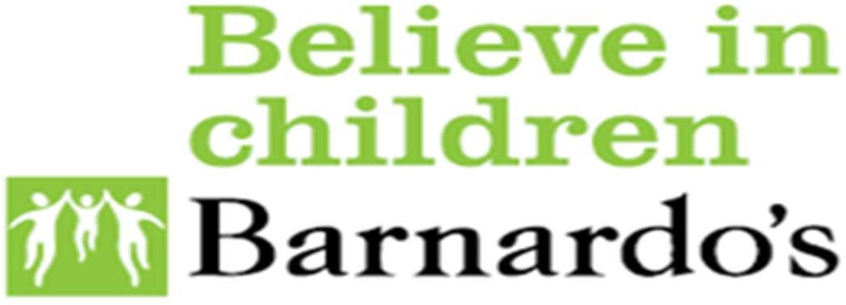
SOUTH TEES

Information for Parents and Carers

What if I do not agree with decisions about SEN provision?
If you are not happy about the help that your child has at school the first step is to talk to their teacher, or to the Special Educational Needs Coordinator (SENCo) or the Headteacher.
South Tees SENDIASS can help you decide what to do, help you to put your concerns forward, or make a complaint. They can also help you prepare for, and attend a meeting.
South Tees SENDIASS will:
•
•
•
•
•
listen to your concerns
help you sort out the issues
identify other people who can support you help you decide what to do next
explain the law and your rights.

Making a complaint
If you think that the school, college, Middlesbrough Council or Redcar and Cleveland Council could do more, you can complain using their complaints procedure (this is usually available on their website). You can ask them to send you a form or you can write to them using the word ‘complaint’. You will usually need to have tried to resolve your complaint by speaking to the right people before you complain but it is important that you need to;
- be clear about all the issues you want resolved
- state what you want to happen
- give a reasonable time by which you would like a response.
If you are not happy with the outcome of making a complaint or feel that it has not been dealt with properly, South Tees SENDIASS can give you information on what to do next.
If your child has an Education, Health and Care plan (EHCP) and you are not happy with the content of the plan or the school, college or setting named in the plan, you should contact the Special Educational Needs and Disabilities Team at either Middlesbrough council at: sen@middlesbrough.gov.uk or Redcar and Cleveland Council at: contactus@redcar-cleveland.gov.uk South Tees SENDIASS can help you prepare for, and attend a meeting or help you decide what to do next.

Disagreement resolution
Many disagreements can be sorted out by talking with the school, college, local authority, or for health services, the Clinical Commissioning Group.
The disagreement resolution service is there to help resolve disagreements between parents or young people and the organisations that are responsible for making provision for children and young people with special educational needs.
Disagreement resolution services can be used:
  - during Education, Health & Care needs assessments
  - while Education, Health & Care plans are drawn up
  - while waiting for Tribunal appeals
  - at review
  - during reassessments.

Mediation
If your disagreement is one that can be appealed to the Special Educational Needs and Disability Tribunal you can use the Mediation service. This is provided by Chapel Mediation – Sue Hall can be contacted on 07792227526 or email: suehall1@sky.com This service is free and confidential.
If you wish to register an appeal with the First Tier Tribunal (SEN and disability) you first have to consider whether to enter mediation and obtain a certificate saying you have considered it.
You can find out more about mediation in the SEND Code of Practice
https://www.gov.uk/government/publications/send-code-of-practice-0-to-25 sections 11.13 to 11.38 or by discussing your problem with South Tees SENDIASS.

If you would like help or want to discuss how we can support, you to resolve any problems please call:
Barnardo’s SENDIASS on 07923 241142
or email southteessendiass@barnardos.org.uk

Barnardo’s Registered Charity Nos. 216250 and SC037605 www.barnardos.org.uk

